|  |  |
| --- | --- |
| **Nikon AF-S 50mm F 1.8G Lens**  Ống kính Nikon AF-S 50mm F/1.8G  Ống kính Nikon 50mm F1.8G.1 Ống kính Nikon 50mm F1.8G.4 Ống kính Nikon 50mm F1.8G.6 Ống kính Nikon 50mm F1.8G.2 | **Featured information:**   * Anti-vibration: No * Aperture: F/1.8-16 * Closest focusing distance: 45cm * Filter size: 58mm   Price: 900$  **Specifications:**   * **Focal distance:** 50mm * **Largest Aperture:** f/1.8 * **Smallest Aperture:** f/16 * **Lens Mount:** Nikon F * **Lens Format:** Full-Frame * **View:** 47° * **Minimum Focus Distance:** 45 cm * **Magnification:** 0.15x * **Optical Components:** 7 Elements in 6 Groups * **Number of Mouth Blades:** 7 * **Focus Type:** Auto focus * **Anti-Vibration:** No * **Filter Size:** 58 mm (Front) * **Size:** 72.1 x 52.4 mm * **Weight:** 185 g |

**Description:**

**Integrated IS optical image stabilizer**

The lens is equipped with an Image Stabilization optical anti-shake system that provides effective anti-shake capabilities when shooting handheld. At the same time, increasing anti-shake ability up to 3.5 steps helps the lens work better in low light or low shutter speeds. In addition, this anti-shake mechanism also allows reducing the shutter speed to 1/15s but still ensures maximum sharpness for the frame. This is an important function for close-up shots or users who have to frequently change shooting angles.

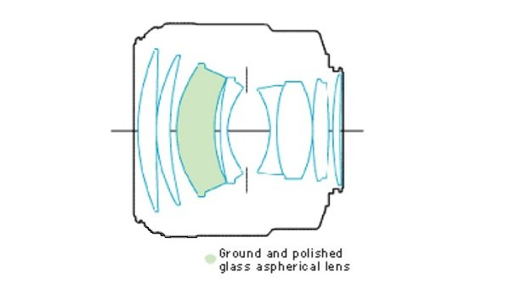

**Take photos with beautiful bokeh effects**

The sturdy, durable lens structure is highly appreciated in Canon's L lens series. The Canon EF 135mm f/2L USM lens is dust and moisture resistant to work stably in harsh environments. The rounded 8-blade diaphragm design contributes to smooth focus quality. It also offers an advantage when used with shallow depth of field and selective focus techniques.

